DISPOSABLE HEEL TAPE
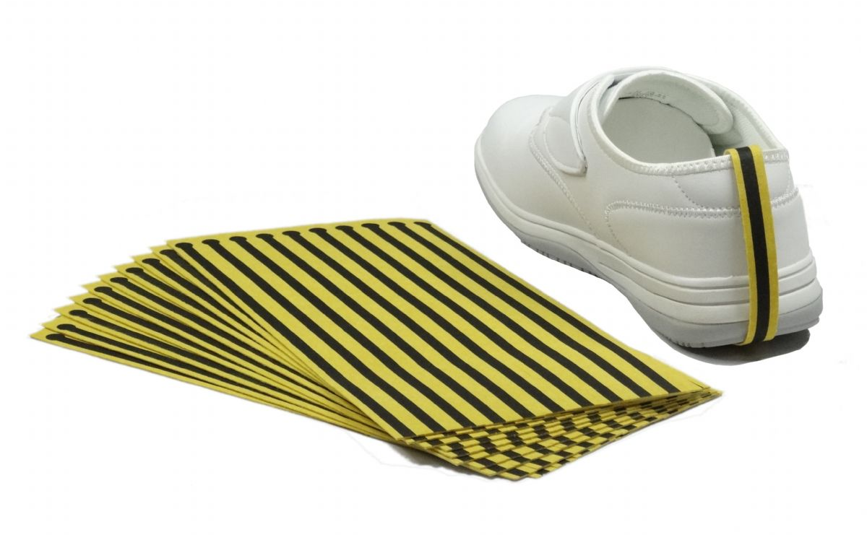
Description:
The Disposable Heel Strap is designed to provide effective ESD (Electrostatic Discharge) protection by grounding the person wearing it. It ensures a reliable connection to the ground, preventing static electricity buildup, which can damage sensitive electronic components. This product is suitable for use in environments where static control is crucial, such as electronic manufacturing and assembly lines.

Features:
- Material: Durable, conductive Fabric
- Size: One size fits all with adjustable strap
- Color: Black and Yellow
- Usage: Single-use
- Conductivity: Meets ESD standards
- Comfort: Lightweight and comfortable for prolonged use
- Compliance: Complies with industry ESD standards
Applications:
Electronics manufacturing
Assembly lines
Cleanrooms
Laboratories
Other static-sensitive environments

Benefits:
Reduces the risk of ESD damage to electronic components
Easy to use and dispose of
Ensures compliance with ESD safety standards
Cost-effective solution for ESD protection

Packaging:
The product is available in packs of 100 heel straps, ensuring a convenient supply for industrial use.

Instructions for Use:
Place the heel strap on the heel of your shoe.
Adjust the strap to fit securely around your heel.
Ensure the conductive fabric makes contact with your skin for effective grounding.
Use in conjunction with other ESD protective measures for optimal protection.

